1. **What is software ? What is software engineering ?**

* Software is operating systems, which allow for easy use of a computer's processing power, as well as applications like Notepad and Firefox.
* Software engineering is the application of principles used in the field of engineering, which usually deals with physical systems, to the design, development, testing, deployment and management of software systems.

1. **Explain types of software.**

* Application software.
* System software.
* Driver software.
* Middleware.
* Programming software.

1. **What is SDLC? Explain each phase of SDLC.**

* An SDLC (software development life cycle) is a big-picture breakdown of all the steps involved in software creation (planning, coding, testing, deploying, etc.).
* Systems development life cycle phases include planning, system analysis, system design, development, implementation, integration and testing, and operations and maintenance.

1. **What is DFD? Create a DFD diagram on Flipkart.**

* A data flow diagram (DFD) is a graphical or visual representation using a standardized set of symbols and notations to describe a business's operations through data movement.

**DFD diagram on Flipkart**

1. **What is Flow chart? Create a flowchart to make addition of two numbers**

* A diagram that shows the connections between different stages of a process or parts of a system

**Flow chart :**

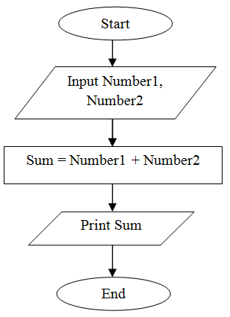

1. **What is Use case Diagram? Create a use-case on bill payment on paytm.**

* A use case diagram shows various use cases and different types of users the system has and will often be accompanied by other types of diagrams as well.

**Use-case on bill payment on paytm**